
HIGH LEVEL DESIGN
Azure Virtual Desktop — Secure Vendor Access

AVD — CQC VENDOR SECURE ACCESS
High Level Design — third-party vendor access to internal database resources

Document Reference: | HLD-AVD-CQC-001
Version: | 0.1 — DRAFT
Classification: | OFFICIAL — Internal / Confidential
Date: | 16 July 2026
Solution Architect: | [Name, Title]
Organisation / Department: | Care Quality Commission — Technology & Digital
Cloud Region (Primary): | UK South
Cloud Region (Secondary): | UK West
Cloud Subscription: | [Subscription Name / ID]

Table of Contents
Table of Contents 2
1. Executive Summary 4
1.1 Document Purpose 4
1.2 Document Scope 4
1.3 Assumptions and Constraints 4
2. Document Information 6
2.1 Version History 6
2.2 Reviewers & Approvers 6
2.3 Related Documents 6
3. Requirements Summary 7
3.1 Non-Functional Requirements (NFRs) 7
4. Solution Overview 9
4.1 Architecture Vision 9
4.2 Logical Architecture Diagram 9
4.3 Key Architectural Decisions 9
5. Cloud Components & Services 11
5.1 Subscription & Management Group Structure 12
6. Network Architecture 13
6.1 Network Topology 13
6.2 Address Space & Subnet Design 14
6.3 Hybrid Connectivity 15
6.4 DNS Strategy 15
6.5 Egress & Ingress Traffic Flows 15
7. Security Architecture 17
7.1 Identity & Access Management 17
7.2 Security Controls 17
7.3 Data Security & Privacy 18
7.4 Threat Model Summary 18
8. Data Architecture 20
8.1 Data Flow Overview 20
8.2 Data Store Design 21
8.3 Data Lifecycle & Retention 21
9. Integration Architecture 22
9.1 Integration Patterns 22
9.2 Database Access & Tooling 22
10. Resilience, HA & Disaster Recovery 23
10.1 Availability Strategy 23
10.2 Disaster Recovery 23
10.3 Backup Strategy 23
11. Operational Architecture 25
11.1 Monitoring & Observability 25
11.2 CI/CD & DevOps 25
11.3 Patch & Update Management 25
11.4 Capacity Management 26
12. Governance & Compliance 27
12.1 Policy & Compliance 27
12.2 Regulatory Compliance 27
13. Cost Estimate 28
13.1 Cost Optimisation Recommendations 29
14. Open Issues & Decisions 30
Appendix A – Well-Architected Framework Alignment 31
Appendix B – Glossary 31
Appendix C – Reference Architecture Links 32

Note: After opening this document in Microsoft Word, right-click the Table of Contents and select 'Update Field' to populate page numbers.

1. Executive Summary
This High Level Design (HLD) describes a secure Azure Virtual Desktop (AVD) solution that lets Care Quality Commission (CQC) third-party vendors access internal database resources without granting them direct network connectivity to the CQC estate. Vendors connect to a hardened, brokered Windows desktop hosted inside CQC's Azure landing zone; the desktop — not the vendor's own device — reaches the databases. Sign-in is permitted only from pre-approved trusted public IP addresses, enforced by Microsoft Entra ID Conditional Access, and every session is protected against data exfiltration so that only screen pixels ever leave the CQC boundary.

Scope: This HLD covers brokered vendor access to internal databases via Azure Virtual Desktop: identity and Conditional Access (trusted-IP restriction), network topology and private database connectivity, session-host build and data-exfiltration controls, resilience, operations and indicative cost. Detailed configuration (Conditional Access policy definitions, Bicep, and GPO/Intune baselines) is delivered in the accompanying Low Level Design.

1.1 Document Purpose
The purpose of this document is to:
- Define the end-to-end architecture for secure CQC vendor access to internal databases via Azure Virtual Desktop
- Specify how Conditional Access restricts vendor connections to trusted IP addresses only
- Describe the identity, network and in-session controls that keep CQC data inside the boundary
- Provide the basis for cost estimation, the Low Level Design, and security sign-off
- Serve as the reference for Architecture Review Board (ARB) approval

1.2 Document Scope
This design covers the secure vendor-access solution end to end. The following are in and out of scope:
- In Scope: AVD host pool and session hosts, Entra ID identity and Conditional Access (trusted-IP), hub-and-spoke networking, private and hybrid database connectivity, in-session data-loss controls, monitoring and indicative cost.
- Out of Scope: changes to the internal databases themselves, vendor-side device build and networking, application-level data modelling, and third-party procurement of vendor licences.

1.3 Assumptions and Constraints
Assumption 1: | An Azure landing zone (management groups, hub connectivity, policy baseline) exists or will be provisioned before deployment.
Assumption 2: | Hybrid connectivity (ExpressRoute or Site-to-Site VPN) to on-premises databases is in place where on-prem databases are in scope.
Assumption 3: | Microsoft Entra ID is the authoritative identity provider; vendors are licensed with an eligible Microsoft 365 / Windows licence assigned in the CQC tenant.
Constraint 1: | External / cloud-only identities require Entra-joined session hosts on Windows 11 24H2 (KB5065789+) and cannot use Kerberos/NTLM to reach on-premises resources.
Constraint 2: | All data and AVD metadata must remain within the UK data boundary (UK South / UK West).
Constraint 3: | Conditional Access is enforced after first-factor authentication and is not a network / DoS control; defence-in-depth is required.

2. Document Information

2.1 Version History
Version | Date | Author | Status | Description
0.1 | 16 Jul 2026 | [Author] | Draft | Initial draft — AVD vendor secure access HLD
1.0 | [Date] | [Author] | Approved | Approved by Architecture Review Board

2.2 Reviewers & Approvers
Name | Role | Organisation | Responsibility
[Name] | Solution Architect | CQC | Document Owner
[Name] | Technical Lead — EUC / AVD | CQC | Technical Sign-off
[Name] | Security Architect | CQC | Security Review
[Name] | Data Protection Officer | CQC | DPIA / UK GDPR Sign-off
[Name] | Cloud Operations | CQC | Operational Acceptance

2.3 Related Documents
Document | Reference / Link
Requirements Specification | [REQ-DOC-001]
Azure Landing Zone Design | [LZ-DOC-001]
Conditional Access Policy Register | [SEC-CA-001]
Data Protection Impact Assessment (DPIA) | [DPIA-001]
Low Level Design — AVD (TBC) | [LLD-AVD-001]

3. Requirements Summary
The following table summarises the key requirements driving this architecture. For the full requirements specification refer to [REQ-DOC-001].

Req ID | Requirement | Type | Priority
REQ-001 | Third-party vendors can access internal database resources through a brokered Azure Virtual Desktop, without direct network access to CQC systems | Functional | High
REQ-002 | Vendor sign-in is permitted only from pre-approved trusted public IP addresses | Security | High
REQ-003 | Multi-factor authentication is enforced for every vendor connection | Security | High
REQ-004 | No CQC data may leave the session boundary (clipboard/drive/print/USB egress disabled; screen capture blocked) | Security | High
REQ-005 | All data and metadata remain within the UK and every access is fully audited | Compliance | High
REQ-006 | Vendor access is time-bound, recertified, and removed on contract end | Compliance | Medium

3.1 Non-Functional Requirements (NFRs)
Availability Target: | 99.99% session-host availability (zone-redundant); AVD control plane per Microsoft SLA
RTO (Recovery Time Objective): | < 4 hours (session hosts rebuilt from image in secondary region)
RPO (Recovery Point Objective): | < 24 hours profiles / < 5 minutes database (Azure SQL failover group)
Max Concurrent Vendors: | [e.g. 25 concurrent / 60 named]
Session Performance: | < 150 ms round-trip; RDP Shortpath (UDP) preferred over TCP fallback
Trusted-IP Enforcement: | 100% of vendor sign-ins gated by Conditional Access named location
Data Residency: | All data and AVD metadata within the UK (UK South / UK West)
Session Data Handling: | No data at rest on the vendor device; device redirection disabled; data rendered in-session only
Logging & Audit Retention: | Sign-in and session logs retained [e.g. 12 months] in Log Analytics / Microsoft Sentinel
Regulatory / Compliance: | Cyber Essentials Plus, UK GDPR / DPA 2018, NHS Data Security & Protection Toolkit, ISO 27001

4. Solution Overview

4.1 Architecture Vision
The solution applies a Zero Trust, data-stays-inside model. Rather than issuing vendors a VPN or opening database ports to the internet, CQC brokers a managed Azure Virtual Desktop session. Vendors authenticate to Microsoft Entra ID, where Conditional Access verifies that the connection originates from a trusted vendor IP range and that multi-factor authentication is satisfied before any session is established. Because AVD uses reverse-connect transport, session hosts expose no inbound ports and are never directly reachable from the internet.
Session hosts run Windows 11 Enterprise multi-session, are Microsoft Entra joined, and sit in a dedicated spoke of a hub-and-spoke network. From the session host, vendors reach Azure SQL databases privately over Azure Private Link and on-premises databases over ExpressRoute / VPN through the hub firewall. Network Security Groups and Application Security Groups constrain the session hosts to only the specific database hosts and ports required.
Architecture Principle: This solution applies Zero Trust — verify explicitly, least privilege, assume breach — with a data-stays-inside model: vendors receive a brokered desktop, never direct network access, and only screen pixels leave the CQC boundary. It aligns to the Microsoft Azure Well-Architected Framework and Microsoft's AVD enterprise-scale guidance.
Data-exfiltration controls ensure vendors can work with the data but cannot remove it: clipboard, drive, printer and USB redirection are disabled, screen-capture protection and watermarking are enabled, App Control for Business restricts the desktop to approved database tooling, and Microsoft Defender and Purview provide threat protection and data-loss prevention. All identity, session and network activity is logged to Microsoft Sentinel within the UK region.

4.2 Logical Architecture Diagram
The diagram below shows the end-to-end vendor access path: from the vendor's trusted network, through Microsoft Entra ID Conditional Access, to the Microsoft-managed AVD control plane, and into the CQC landing zone where session hosts reach the databases over private connectivity.

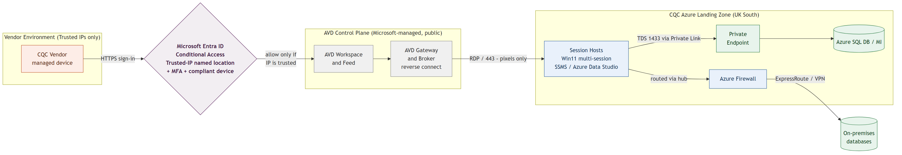

Figure 1: Logical Architecture Overview

4.3 Key Architectural Decisions
Decision | Rationale
Brokered AVD desktop (no direct network access) | Vendors reach data through a controlled desktop; databases are never exposed to vendor networks or the internet
Trusted-IP Conditional Access | Only pre-approved vendor public IPs can sign in; enforced at the Entra identity layer (the AVD gateway is a public Microsoft endpoint)
Reverse-connect transport (no inbound ports) | Session hosts expose no RDP / inbound ports and are unreachable from the internet
Entra-joined Windows 11 multi-session hosts | Required for external identities and single sign-on; lowest-cost brokered desktop option
Private Link + hub-and-spoke networking | Database traffic stays on the Microsoft / CQC private network; session egress is allow-listed
Data-in-place session controls | Redirection disabled, screen-capture protection, watermarking and DLP prevent data leaving the session
UK South / UK West only | Meets UK data residency obligations for CQC as a regulated public-sector body

5. Cloud Components & Services
The following table lists all cloud services considered for this solution, their proposed SKUs, target regions, and whether they are in scope for this phase of delivery. Update the In Scope column to reflect confirmed services.

Azure Service | SKU / Tier | Region | Purpose | In Scope?
AVD Platform
Azure Virtual Desktop (host pool, workspace, app groups) | Pooled, multi-session | UK (metadata) / UK South | Brokered desktop delivery to vendors | Yes
Session host VMs (Win11 Ent multi-session 24H2) | D4as v5 (4 vCPU / 16 GB) | UK South | Vendor session compute (Entra-joined) | Yes
Azure Compute Gallery | N/A | UK South / West | Golden-image versioning & replication | Yes
Azure VM Image Builder / Custom Image Templates | N/A | UK South | Automated golden-image pipeline | Yes
Azure Files (FSLogix profiles) | Premium, Entra Kerberos | UK South | Roaming profiles (cloud-only identity support) | Yes
Identity & Access
Microsoft Entra ID | P2 | Global | Vendor identities, MFA, Conditional Access, PIM | Yes
Microsoft Entra ID Governance | Add-on | Global | Access packages & access reviews for vendors | Yes
Microsoft Intune | Incl. in M365 | Global | Session-host config, DLP and App Control policies | Yes
Networking
Azure Virtual Network (hub + AVD spoke) | N/A | UK South | Private network isolation | Yes
Azure Firewall | Premium | UK South | Egress allow-list (AVD FQDN tag + DB endpoints) | Yes
Azure Private Endpoint / Private Link | N/A | UK South | Private connectivity to Azure SQL | Yes
ExpressRoute / VPN Gateway | ErGw1 / VpnGw2 | UK South | Hybrid connectivity to on-prem databases | Cond.
Azure Bastion | Standard | UK South | Secure administrative access to session hosts | Yes
Azure DNS Private Resolver | N/A | UK South | Private DNS + on-prem conditional forwarding | Yes
Data & Databases
Azure SQL Database / Managed Instance | General Purpose (as sized) | UK South | Target relational data (Private Link, Entra auth) | Cond.
On-premises databases (SQL / Oracle) | Existing | On-premises | Existing internal data over ExpressRoute / VPN | Cond.
Security & Operations
Microsoft Defender for Cloud / Endpoint | Plan 2 | Global | Threat protection on session hosts | Yes
Microsoft Sentinel | Pay-as-you-go | UK South | SIEM — sign-in & session monitoring | Yes
Microsoft Purview (Endpoint DLP / IRM) | Incl. M365 E5 | Global | Data-loss prevention, forensic evidence | Recommended
Azure Monitor / Log Analytics | Pay-as-you-go | UK South | AVD Insights, diagnostics, alerting | Yes
Azure Key Vault | Standard | UK South | Secrets (DB SQL-auth creds, join secrets) | Yes
Azure Policy | Built-in | Global | Governance guardrails | Yes

5.1 Subscription & Management Group Structure
The AVD workload is deployed into a dedicated application (spoke) landing zone under CQC's Azure management group hierarchy, aligned to the CQC Azure Landing Zone. Session hosts, profile storage and private endpoints reside in the AVD spoke subscription; shared connectivity and security services (Azure Firewall, gateways, Bastion, DNS) reside in the platform / connectivity subscription.

Management Group: | corp > workloads > production (CQC landing zone)
Subscription Name: | sub-cqc-avd-vendor-prod
Subscription ID: | [00000000-0000-0000-0000-000000000000]
Resource Group Strategy: | rg-avd-hostpool, rg-avd-storage, rg-avd-network, rg-avd-mgmt
Tagging Strategy: | Environment, CostCentre, Owner, Project, DataClassification
Resource Naming Convention: | <type>-cqc-avd-<env>-uks-<instance>

6. Network Architecture

6.1 Network Topology
The design uses a hub-and-spoke topology with hybrid connectivity, following Microsoft's AVD enterprise-scale guidance. Session hosts are isolated in a dedicated AVD spoke VNet; the hub VNet holds shared services only. VNet peering connects the spoke to the hub, and the spoke uses the hub's gateway (gateway transit) to reach on-premises databases.
The hub contains Azure Firewall Premium (in AzureFirewallSubnet), the ExpressRoute / VPN gateway (GatewaySubnet), Azure Bastion (AzureBastionSubnet) for administrative access, and Azure DNS Private Resolver. User-defined routes force session-host egress through Azure Firewall, with a service-tag exception for AVD control-plane traffic (WindowsVirtualDesktop, next hop Internet) to prevent session drops during firewall scale-in.
Pattern: Hub-and-Spoke with hybrid connectivity, per Microsoft's AVD enterprise-scale guidance. A dedicated AVD spoke VNet isolates the session hosts; the hub hosts shared Azure Firewall, ExpressRoute / VPN gateway, Bastion and DNS. Session-host egress is forced through the hub firewall and allow-listed to the AVD control plane and the specific database endpoints only.

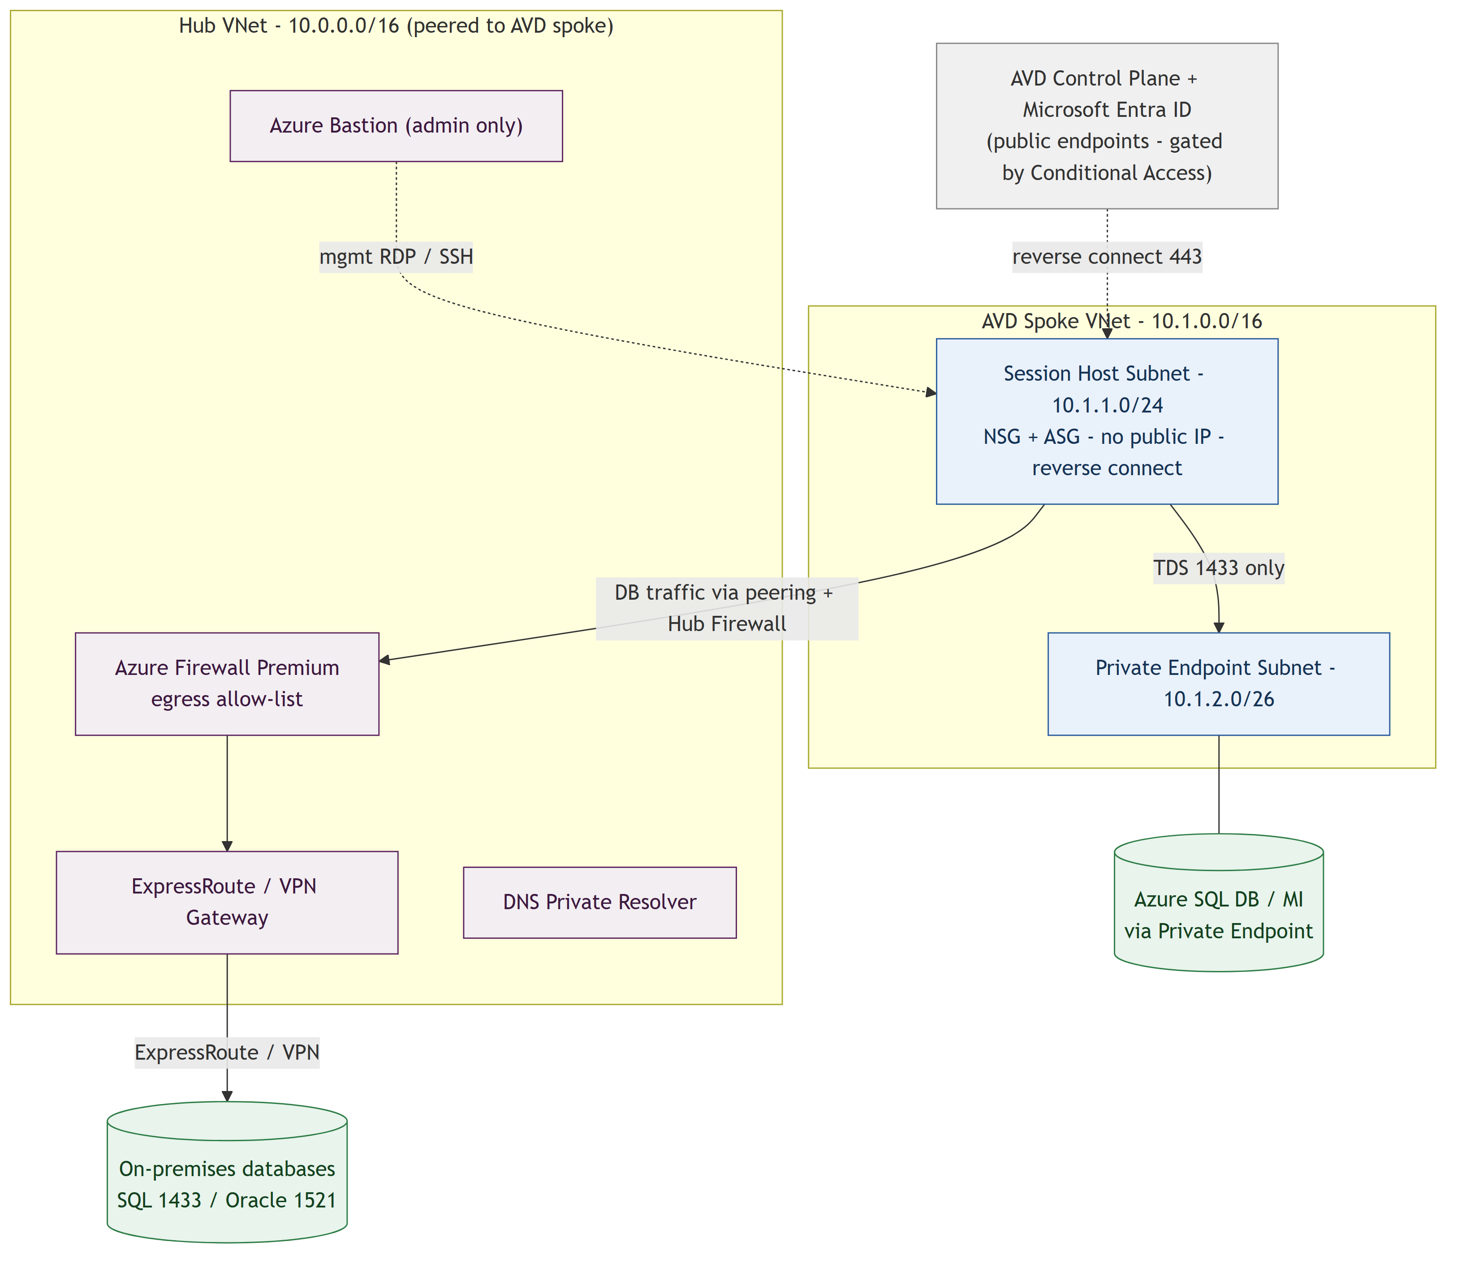

Figure 2: Network Topology — Hub-and-Spoke

6.2 Address Space & Subnet Design
Hub VNet CIDR: | 10.0.0.0/16
AVD Spoke VNet CIDR: | 10.1.0.0/16
Private Endpoint / Data range: | 10.1.2.0/26

Zone | Subnet / CIDR | NSG Applied | Resources
Session Hosts | 10.1.1.0/24 | NSG-AVD-Hosts + ASG | Windows 11 multi-session session hosts (no public IP)
Private Endpoints | 10.1.2.0/26 | NSG-PE (network policies on) | Private endpoints for Azure SQL Database / MI
Azure Firewall | 10.0.1.0/26 | — (AzureFirewallSubnet) | Azure Firewall Premium
Gateway | 10.0.2.0/27 | — (GatewaySubnet) | ExpressRoute / VPN gateway
Bastion | 10.0.3.0/26 | NSG-Bastion (AzureBastionSubnet) | Azure Bastion for admin access
DNS Resolver | 10.0.4.0/28 | Delegated subnets | Azure DNS Private Resolver (inbound / outbound)

6.3 Hybrid Connectivity
On-premises databases are reached over the existing hybrid connection through the hub. Where only Azure PaaS databases are in scope, hybrid connectivity is not required for data access.

Connectivity Method: | ExpressRoute (preferred) or Site-to-Site VPN — via the shared hub gateway
ExpressRoute Circuit: | [Provider, bandwidth, SKU — if applicable]
VPN Gateway SKU: | [e.g. VpnGw2 — if VPN is used]
On-Premises Networks: | [CIDR ranges of the on-premises database subnets]
Routing: | Gateway transit from the AVD spoke; UDR forces database traffic via the Hub Firewall

6.4 DNS Strategy
Private DNS is used so that database private endpoints resolve to private IP addresses, with conditional forwarding for on-premises name resolution.
- Private DNS zone privatelink.database.windows.net linked to the AVD spoke and hub VNets for Azure SQL private endpoints
- Azure DNS Private Resolver in the hub provides conditional forwarding to and from on-premises DNS
- On-premises DNS conditionally forwards the public zone (database.windows.net) to the Private Resolver inbound endpoint — not the privatelink zone
- Applications connect using the standard server FQDN (server.database.windows.net), never the privatelink FQDN or IP

6.5 Egress & Ingress Traffic Flows
Vendor Sign-in (Internet → Entra): | Vendor (trusted IP) → HTTPS → Microsoft Entra ID (Conditional Access) → AVD Gateway
Brokered Session (Gateway → Host): | AVD Gateway → reverse-connect 443 (+ RDP Shortpath UDP 3478) → session host (no inbound ports)
Session → Azure Database: | Session host → Private Endpoint (TDS 1433) → Azure SQL (no public exposure)
Session → On-prem Database: | Session host → Hub Firewall → ExpressRoute / VPN → on-prem SQL 1433 / Oracle 1521
Session → Internet: | Denied by default; Azure Firewall allows only the required AVD control-plane FQDNs

7. Security Architecture
Framework: This design adheres to the Microsoft Zero Trust model — verify explicitly, use least privilege access, assume breach. All controls below map to this principle.

7.1 Identity & Access Management
Vendors are represented by dedicated identities in the CQC Microsoft Entra ID tenant (either cloud-only accounts managed by CQC, or Entra B2B guest identities), placed in a dedicated security group and licensed with an eligible Microsoft 365 or Windows licence assigned in the CQC tenant. Access to the AVD desktop is granted via the Desktop Virtualization User role on the application group and the Virtual Machine User Login role on the Entra-joined hosts. No standing administrative access is granted; all privileged roles are activated just-in-time through Microsoft Entra PIM.

Identity Provider: | Microsoft Entra ID (CQC tenant)
Vendor Identities: | Dedicated cloud accounts (or Entra B2B guests) in security group SG-AVD-Vendors
Authentication: | OpenID Connect / OAuth 2.0; single sign-on to Entra-joined session hosts (Windows Cloud Login)
MFA Policy: | Mandatory via Conditional Access on the Azure Virtual Desktop (9cdead84…) and Windows Cloud Login (270efc09…) apps
Conditional Access: | Trusted-IP named location (block all except trusted); legacy per-user MFA disabled
Privileged Access: | Microsoft Entra PIM — just-in-time activation for AVD / Owner / Contributor roles
RBAC Model: | Desktop Virtualization User on the app group + Virtual Machine User Login on hosts; assigned to groups, not individuals

7.2 Security Controls
The following controls are mandated for this solution. All controls must be validated during the security review and sign-off process.

Domain | Control | Azure Service | Status | Owner
Identity | Multi-Factor Authentication | Microsoft Entra ID Conditional Access | Required | Security Arch
Identity | Trusted-IP sign-in restriction | Entra CA named location (block non-trusted) | Required | Security Arch
Identity | Privileged access (just-in-time) | Microsoft Entra PIM | Required | Security Arch
Identity | Vendor lifecycle & access reviews | Microsoft Entra ID Governance | Required | IAM
Endpoint | No local admin + application allow-listing | App Control for Business (WDAC) | Required | Platform
Endpoint | Screen-capture protection | AVD SCP (block on client and server) | Required | Platform
Endpoint | Session watermarking (traceability) | AVD watermarking (Connection ID) | Recommended | Platform
Endpoint | Device-redirection lockdown | Host pool RDP properties (clipboard/drive/print/USB off) | Required | Platform
Endpoint | EDR threat protection | Microsoft Defender for Endpoint | Required | SOC
Data | Endpoint DLP / Insider Risk | Microsoft Purview | Recommended | Data Gov
Network | Egress allow-list | Azure Firewall (WindowsVirtualDesktop FQDN tag) | Required | Network
Network | Private data path | Azure Private Link / Private Endpoint | Required | Network
Network | Micro-segmentation | NSG + ASG (allow 1433, deny all else) | Required | Network
Operations | Audit logging & SIEM | Microsoft Sentinel + Log Analytics | Required | SOC

7.3 Data Security & Privacy
Data Classification: | OFFICIAL — CQC internal / personal data as applicable
Data-in-Place Principle: | Data is rendered in-session only; no data at rest on the vendor device; device redirection disabled
Encryption at Rest: | Azure Storage SSE / TDE (Azure SQL); BitLocker on the session-host OS disk
Encryption in Transit: | TLS 1.2+; RDP over reverse-connect (443); Private Link for database traffic
Key Management: | Azure Key Vault (soft-delete + purge protection) for SQL-auth credentials and join secrets
Data Loss Prevention: | Purview Endpoint DLP + screen-capture protection + watermarking; Insider Risk Management

7.4 Threat Model Summary
The table below summarises key threats using STRIDE and the controls that mitigate them. The central risk — a vendor exfiltrating CQC data — is mitigated in depth by identity, network and in-session controls rather than any single measure.
STRIDE | Threat | Mitigation | Azure Service
Spoofing | Credential theft / access from an untrusted location | Trusted-IP CA + MFA + Entra ID Protection | Entra ID CA
Tampering | Data modified in transit | TLS 1.2+, Private Link, RDP encryption | Private Link, Azure SQL
Repudiation | Vendor denies actions taken in session | Sign-in & session audit; watermarking traceability | Sentinel, AVD Insights
Info Disclosure | Data exfiltration through the session | Redirection disabled, SCP, DLP, no internet browsing | RDP properties, Purview
Denial of Service | Attack on the public AVD gateway | Microsoft-managed gateway resilience; CA is not a DoS control | AVD platform, Azure DDoS
Elevation of Privilege | Local admin abuse / lateral movement | No local admin, WDAC, NSG/ASG, Entra PIM | WDAC, Entra PIM

8. Data Architecture

8.1 Data Flow Overview
The flow below shows how a vendor connection is evaluated and how data is kept in place. Conditional Access decides at sign-in whether the connection is permitted; once a session is granted, data is rendered on the session host and only screen output is transmitted to the vendor.

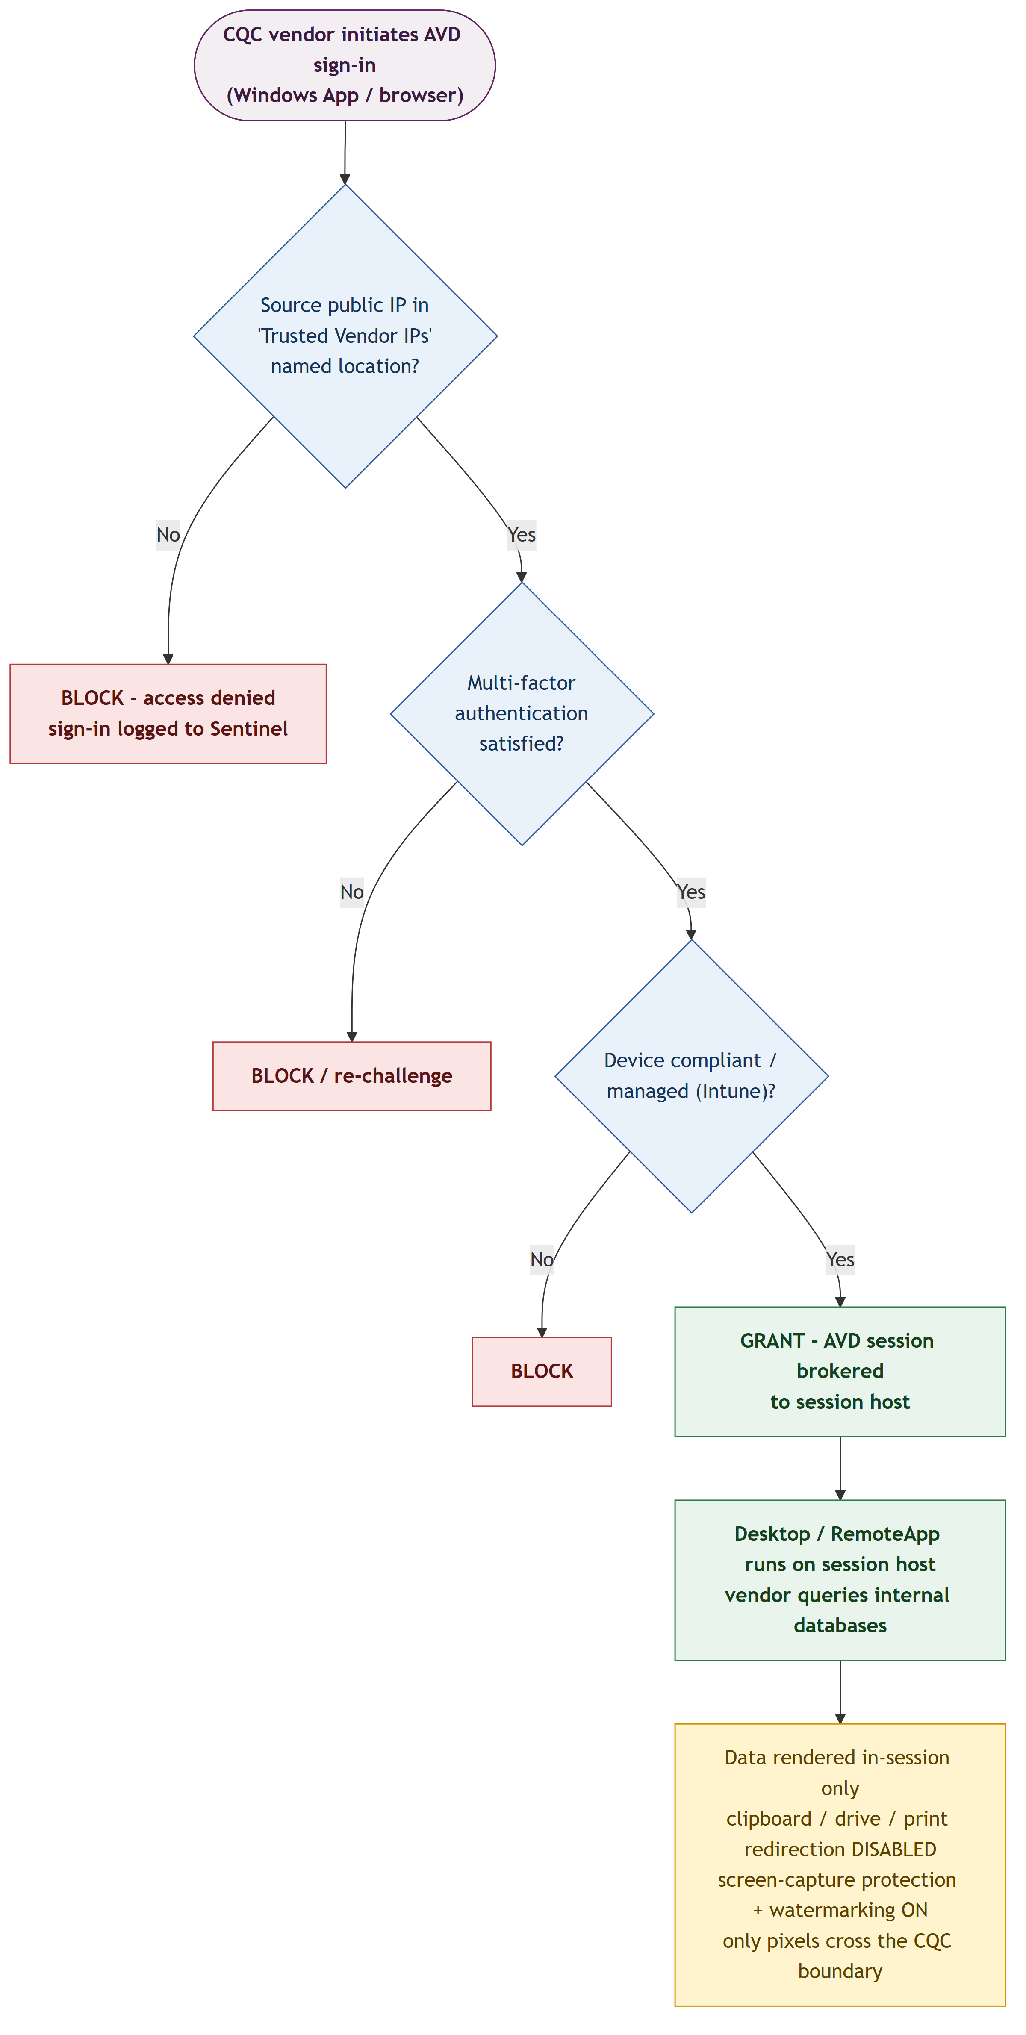

Figure 3: Vendor Sign-in Conditional Access & Data-in-Place Flow

8.2 Data Store Design
Target Databases (Azure): | Azure SQL Database / Managed Instance — accessed via Private Link using Microsoft Entra authentication
Target Databases (On-prem): | SQL Server (1433) / Oracle (1521) — reached over ExpressRoute/VPN; SQL authentication (Kerberos/NTLM unavailable to external identities)
Database Tooling: | SSMS / Azure Data Studio / Oracle client delivered via the golden image or MSIX App Attach on session hosts
User Profiles: | FSLogix profile containers on Azure Files (Premium, Entra Kerberos) — supports cloud-only identities
Secrets: | Azure Key Vault — SQL-auth credentials, storage keys and join secrets
Session Compute: | Windows 11 Enterprise multi-session 24H2, Entra-joined, ephemeral (rebuilt from image)
Diagnostics: | Log Analytics workspace — AVD diagnostics, sign-in logs and session events

8.3 Data Lifecycle & Retention
Session Data: | None retained on the client; session-host disks are ephemeral and wiped on reimage
Profile Data: | FSLogix retained per vendor while access is active; removed on offboarding
Audit / Sign-in Logs: | Retained [e.g. 12 months] in Log Analytics; [e.g. 2 years] in Microsoft Sentinel / archive
Database Data: | Governed by source-system retention (unchanged by AVD access)
Offboarding: | Identity disabled then removed (access-review auto-disable-then-delete); profile and assignments removed

9. Integration Architecture

9.1 Integration Patterns
The AVD desktop is the single, controlled integration point between vendors and CQC's databases. The table below lists the database connectivity paths and the AVD control-plane egress the session hosts require.

Connection | Direction | Protocol / Port | Azure Service | Notes
Azure SQL Database | Session → DB | TDS 1433 (Private Link) | Private Endpoint | Entra auth; Redirect mode needs 1433–65535 open
Azure SQL Managed Instance | Session → DB | TDS 1433 | Private Endpoint (Proxy) | PE is always Proxy on 1433
On-premises SQL Server | Session → DB | TDS 1433 | ExpressRoute / VPN via Hub FW | SQL authentication (no Kerberos for external ids)
On-premises Oracle | Session → DB | 1521 | ExpressRoute / VPN via Hub FW | Oracle client delivered on the session host
AVD control plane | Session → Service | HTTPS 443 / UDP 3478 | WindowsVirtualDesktop FQDN tag | Reverse-connect; allow-listed egress only

9.2 Database Access & Tooling
- Database client tools (SSMS, Azure Data Studio, Oracle client) are delivered on the session host via the golden image or MSIX App Attach — not installed by vendors
- Azure SQL connections use Microsoft Entra authentication over Private Link (no stored passwords) where supported
- On-premises database connections use SQL authentication with per-vendor credentials stored in Azure Key Vault (external / cloud-only identities cannot use Kerberos/NTLM)
- Least-privilege database accounts are scoped to only the schemas and objects each vendor requires
- All database access is logged at the source database and correlated with AVD session and sign-in logs in Microsoft Sentinel

10. Resilience, HA & Disaster Recovery

10.1 Availability Strategy
Session hosts are distributed across availability zones in UK South for a 99.99% VM SLA, with autoscale controlling capacity and cost. The AVD control plane is Microsoft-managed and globally resilient. For regional resilience, an active-passive host pool can be stood up in UK West from the same golden image.

Availability Zone Strategy: | Session hosts spread across AZ1–AZ3 in UK South (99.99% VM SLA)
Autoscale: | Scaling plan (ramp-up / peak / ramp-down / off-peak) + Start VM on Connect
Load Balancing (host pool): | Breadth-first / depth-first load balancing across session hosts
Control Plane: | Microsoft-managed, globally distributed, automatic regional failover
Health Monitoring: | AVD Insights + Azure Monitor alerts on host availability and connections

10.2 Disaster Recovery
Component | RTO | RPO | DR Strategy | Azure Implementation
AVD control plane | Managed | Managed | Microsoft-managed geo-failover | Globally distributed; automatic
Session hosts (pooled) | < 4 h | N/A (stateless) | Active-passive UK South → UK West | Redeploy from Azure Compute Gallery image
FSLogix profiles (Azure Files) | < 4 h | < 24 h | Cross-region | Azure Files backup / snapshots; ANF cross-region replication
Identity (Entra ID) | Managed | Managed | Microsoft-managed | Globally resilient
Azure SQL Database | < 1 h | < 5 min | Auto-failover group | Failover group to UK West
Network (hub / spoke) | < 4 h | N/A | IaC redeploy | Bicep redeploy in UK West

10.3 Backup Strategy
Session Hosts: | Stateless — no backup; rebuilt from the golden image in Azure Compute Gallery
FSLogix Profiles: | Azure Files share snapshots + Azure Backup (daily); or ANF snapshots
Golden Image: | Versioned in Azure Compute Gallery; N previous versions retained
Key Vault: | Soft-delete (90 days) + purge protection enabled
Configuration (IaC): | Bicep held in Git; fully redeployable

11. Operational Architecture

11.1 Monitoring & Observability
Metrics: | Azure Monitor — session-host CPU/memory, session counts, connection latency
Logs: | Log Analytics — AVD diagnostics and Windows event logs (Azure Monitor Agent + Data Collection Rule)
AVD Insights: | Azure Monitor workbook — host-pool health, connection diagnostics, user experience
Alerting: | Azure Monitor alerts — host availability, disconnects, capacity; Action Groups to CQC ITSM
SIEM: | Microsoft Sentinel (UK South) — sign-in monitoring (Entra connector), MDE alerts, session events
Sign-in Monitoring: | Entra ID sign-in logs — CA result, source IP, and blocked non-trusted attempts

11.2 CI/CD & DevOps
Source Control: | Azure DevOps Repos / GitHub — IaC and image configuration
Infrastructure as Code: | Bicep — host pool, VNets, firewall policy; Conditional Access via Graph / Terraform
Image Pipeline: | Azure VM Image Builder / Custom Image Templates → Azure Compute Gallery
Session Host Update: | Native Session host update — rolls new VMs from an updated image, preserving host names
Deployment: | Azure DevOps Pipelines / GitHub Actions — dev → test → production
Secrets in Pipelines: | Azure Key Vault references — no plain-text secrets
Config Baseline: | Intune Settings Catalog / GPO — RDP redirection, SCP, watermarking, WDAC

11.3 Patch & Update Management
- Session hosts are patched by redeploying from an updated golden image using the native Session host update feature (not in-place Windows Update)
- Golden images are built by Azure VM Image Builder / Custom Image Templates and versioned in Azure Compute Gallery
- A monthly image refresh incorporates OS and application security updates; Defender for Endpoint provides vulnerability visibility
- SMB shares hosting FSLogix must move to AES-SHA1 Kerberos before the April 2026 Windows Server default encryption change

11.4 Capacity Management
Capacity is managed through the autoscale scaling plan, sizing multi-session density from AVD Insights telemetry and reviewed quarterly with CQC Cloud Operations. Reserved Instances or a Savings Plan cover the baseline; note that Reserved VM Instances for selected VM series cease to be purchasable / renewable from 1 July 2026.
Review Frequency: | Quarterly capacity review with CQC Cloud Operations
Scaling Mechanism: | Autoscale scaling plan (ramp-up / peak / ramp-down / off-peak) + Start VM on Connect
Sizing: | Multi-session density target (users per vCPU) validated by AVD Insights
Reservations: | 1-year Reserved VM Instances / Savings Plan for the baseline (note July 2026 RI change for select series)

12. Governance & Compliance

12.1 Policy & Compliance
Policy Initiative: | HMG OFFICIAL baseline / CIS Microsoft Azure Foundations + custom AVD initiative
Allowed Regions: | UK South, UK West (deny all other regions via Azure Policy)
Allowed VM SKUs: | Approved D-series only (deny GPU / legacy SKUs)
Mandatory Tags: | Environment, CostCentre, Owner, Project, DataClassification (deny on non-compliance)
Defender for Cloud: | Enabled — Servers, Storage, Key Vault, SQL
Compliance Dashboard: | Microsoft Defender for Cloud — Regulatory Compliance blade

12.2 Regulatory Compliance
The solution is designed to meet CQC's obligations as a UK public-sector health and social care body. Data and metadata remain within the UK, and every access is fully audited to support the requirements below.
Standard | Requirement | Status | Evidence
Cyber Essentials Plus | NCSC Cyber Essentials Plus certification | [Compliant / Gap] | [Cert ref]
UK GDPR / DPA 2018 | UK data-protection compliance | [Compliant / Gap] | [DPIA ref]
NHS Data Security & Protection Toolkit | DSPT annual submission (health & social care) | [Compliant / Gap] | [DSPT ref]
ISO 27001 | Information security management system | [Compliant / Gap] | [Audit ref]
Government Security Classifications | OFFICIAL handling of CQC data | [Compliant / Gap] | [Policy ref]

13. Cost Estimate
Disclaimer: The figures below are indicative estimates based on current Azure pricing in UK South at the time of writing. Actual costs will vary based on usage, reserved instance negotiations, and enterprise agreements. Validate using the Azure Pricing Calculator with confirmed SKUs and volumes.

Service | Monthly Est. (£) | Annual Est. (£) | Billing Model | Notes
Session hosts (3× D4as v5, autoscaled ~10h/day) | ~£380 | ~£4,560 | Reserved 1yr + autoscale | Largest AVD cost component
Azure Files Premium (FSLogix, ~1 TB) | ~£130 | ~£1,560 | Provisioned | Profile storage
Azure Firewall Premium (hub share) | ~£730 | ~£8,760 | Fixed + data | Shared hub service — allocate a share if already deployed
ExpressRoute / VPN Gateway (hub share) | ~£110–£930 | — | Fixed | Only if not already present in the hub
Private Endpoints (×2) | ~£15 | ~£180 | Fixed | Azure SQL
Azure Bastion (Standard) | ~£110 | ~£1,320 | Fixed | Administrative access
Log Analytics / AVD Insights | ~£90 | ~£1,080 | Consumption | ~5 GB/day
Microsoft Sentinel | ~£110 | ~£1,320 | Consumption | Security telemetry
Vendor licences (M365 / Windows, per user) | Existing / assigned | — | Per user | Eligible licence in CQC tenant — NOT AVD per-user access pricing
TOTAL (indicative, AVD-specific) | ~£800–£1,700 | ~£10k–£20k |  | Excludes licences and shared hub services already in place

13.1 Cost Optimisation Recommendations
- Use the autoscale scaling plan with Start VM on Connect to power session hosts down outside vendor working hours
- Purchase 1-year Reserved VM Instances or a Savings Plan for baseline session-host compute (note the July 2026 RI change for select series)
- Right-size session-host SKU and multi-session density after a 30-day AVD Insights baseline
- Use pooled multi-session rather than personal host pools to maximise density and minimise cost
- Choose Azure Files Premium sized to the profile footprint; apply storage lifecycle where applicable
- Set Azure Cost Management budgets and anomaly alerts at the AVD subscription level

14. Open Issues & Decisions
The following items require resolution before or during detailed design. Each item must be closed before entering delivery.

ID | Issue / Decision | Impact | Owner | Due Date | Status
OI-001 | Confirm each vendor's static public egress IP ranges for the Trusted Vendor IPs named location | High | Security Arch + Vendor | [Date] | Open
OI-002 | On-prem database authentication — external/cloud-only identities cannot use Kerberos/NTLM; confirm SQL auth vs gMSA/service-broker | High | Data + Security | [Date] | Open
OI-003 | Identity model — dedicated cloud accounts vs Entra B2B guests, plus session-host OS build 24H2 + KB5065789 prerequisite | High | Identity | [Date] | Open
OI-004 | FSLogix for external identities is in preview — confirm supportability or Azure Files Entra Kerberos fallback | Medium | Platform | [Date] | Open
OI-005 | Client strategy — Windows App vs web (screen-capture protection blocks the web client; watermarking needs a full desktop) | Medium | EUC | [Date] | Open
OI-006 | Whether CQC issues managed endpoints to vendors (enabling device-compliance CA) or relies on trusted-IP + MFA only | Medium | Security Arch | [Date] | Open

Appendix A – Well-Architected Framework Alignment
The following summarises how this design maps to the five pillars of the Microsoft Azure Well-Architected Framework (WAF).

WAF Pillar | Design Decisions | Azure Services
Reliability | Zone-redundant session hosts (99.99%), autoscale, Microsoft-managed control plane, active-passive UK West DR | Availability Zones, Autoscale, Compute Gallery
Security | Zero Trust, trusted-IP CA, MFA, reverse-connect, Private Link, SCP/watermarking/DLP, no local admin | Entra ID CA/PIM, Azure Firewall, Private Link, Defender, Purview, WDAC
Cost Optimisation | Autoscale + Start VM on Connect, Reserved Instances/Savings Plan, pooled multi-session, right-sizing | Autoscale, Reservations, Cost Management
Operational Excellence | IaC (Bicep), image pipeline, Session host update, AVD Insights, Sentinel | Azure DevOps, VM Image Builder, Monitor, Sentinel
Performance Efficiency | RDP Shortpath (UDP), multi-session density tuning, zone-local Premium profile storage | RDP Shortpath, FSLogix on Azure Files Premium

Appendix B – Glossary
Term | Definition
AVD | Azure Virtual Desktop — Microsoft's managed desktop and app virtualization service
ARB | Architecture Review Board
ASG | Application Security Group — NSG grouping by workload role
CA | Conditional Access — Microsoft Entra ID policy engine
CIDR | Classless Inter-Domain Routing — IP address range notation
DLP | Data Loss Prevention
DR | Disaster Recovery
DSPT | NHS Data Security and Protection Toolkit
Entra ID | Microsoft Entra ID (formerly Azure Active Directory)
FSLogix | Profile-container technology for roaming user profiles in AVD
HLD / LLD | High Level Design / Low Level Design
IRM | Insider Risk Management (Microsoft Purview)
MFA | Multi-Factor Authentication
Named Location | Entra CA condition defining trusted IP ranges
NSG | Network Security Group
PE | Private Endpoint — Azure Private Link network interface
PIM | Privileged Identity Management — just-in-time role activation
RDP | Remote Desktop Protocol
RemoteApp | AVD delivery of individual published applications (vs full desktop)
Reverse Connect | AVD transport where session hosts make only outbound connections (no inbound ports)
RDP Shortpath | Optional UDP transport for AVD to improve session performance
SCP | Screen Capture Protection
SSO | Single Sign-On
UDR | User-Defined Route
VDA | Virtual Desktop Access licence
WDAC | Windows Defender Application Control (App Control for Business)

Appendix C – Reference Architecture Links
- Azure Architecture Center: https://learn.microsoft.com/en-us/azure/architecture/
- Azure Well-Architected Framework: https://learn.microsoft.com/en-us/azure/well-architected/
- Azure Security Benchmark: https://learn.microsoft.com/en-us/security/benchmark/azure/
- Azure Landing Zones: https://learn.microsoft.com/en-us/azure/cloud-adoption-framework/ready/landing-zone/
- Azure Pricing Calculator: https://azure.microsoft.com/en-gb/pricing/calculator/
- Microsoft Entra ID Documentation: https://learn.microsoft.com/en-us/entra/identity/

